**Practical No 8**

**One Sample hypothesis test:**

**Create a hypothesis set**

> x=c(6.2,6.6,7.1,7.4,7.6,7.9,8,8.3,8.4,8.5,8.6,8.8,8.8,9.1,9.2,9.4,9.4,9.7,9.9,10.2,10.4,10.8,11.3,11.9)

**Perform t test on the set**

> t.test(x-9,alternative = "two.sided",conf.level = 0.95)

Df=degree of freedom

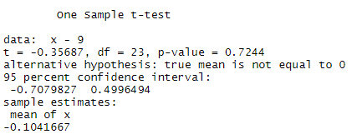

**Create two sets of data**

> x=c(418,421,421,422,425,427,431,434,437,439,446,447,448,453,454,463,465)

> y=c(429,430,430,431,436,437,440,441,445,446,447)

> test2<-t.test(x,y,alternative = "two.sided",mu=0,var.equal = F,conf.level = 0.95)

Mu=population mean

Var.equal(checking two variance are equal or not)

T=pooled variance

F=welch test

> test2

